Burak Kır 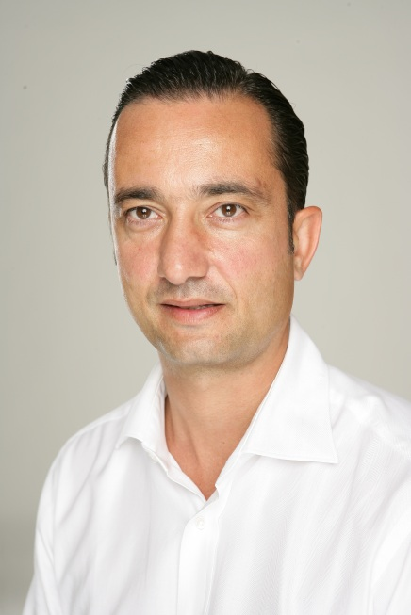

Graduated from Istanbul Technical University, Faculty of Electronics and Communication, Department of Electronics and Communication Engineering in 1990.
After completing his Master's degree in International Marketing in Istanbul University, Faculty of Business Administration the following year, he started his professional career at Koç Holding.
Between 1991 and 1994, he worked as the International Marketing and Sales Coordinator for Beko Elektronik A.Ş. Transferred to RAM Foreign Trade, a foreign trade company of Koç Holding in 1994, Burak Kır established a business in Kazakhstan in order to provide Koç Holding's Automotive, Durable and Fast Consumer Marketing Strategy Coordination and regional management.
He was the General Manager of RAM Henkel Ltd. which was established under the partnership of Türk Henkel and Koç Holding in Kazakhstan between 1997-2001.
Burak Kır, joined Aria-İş-Tim Telekomünikasyon A.Ş. as the sales manager between 2001 and 2004, had carried out his duty as CEO in Artı Teknoloji between years 2004-2018.

Burak Kır has continued establishing startups and set partnerships, between years 1996-2014 in the mobile, digital technologies, and consulting companies in Turkey and abroad in. Tikle Computing Systems, Tactic Enterprise Sales, Foodtech Food Delivery Systems Companies established in Ukraine; Triotech and CoPilot in UK; Tactic Corporate Sales i, Dataport Computing Systems, CMS, Soho Agency, Fisgir and BDO Consulting Industry and Trade Co., Ltd. , DBK in Turkey are some of these companies.

He is fluent in English and Russian, intermediare Italian speaker.
He is a founding member of the Board of Directors of the Turkish Businessmen Association of Kazakhstan (KATIAD).
Since its founding in December 2009, Burak Kır has been the Vice Chairman of the Mobile Service Provider Businessmen Association (MOBİLSAD).

Burak Kır has PhDin the field of marketing MA students in the field of Mobile Marketing, Digital Marketing, High Technology Marketing and e-commerce and internet marketing in English and Turkish in Bilgi and Bahcesehir Universities.

Born in 1969, Burak Kır is married and has two children.

